**Snowflake Metadata Share Guide**

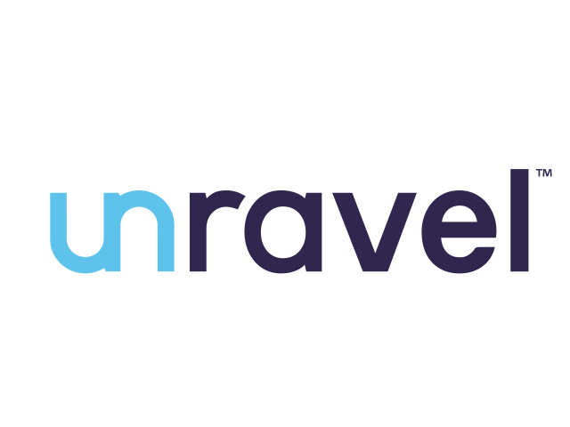

|  |  |
| --- | --- |
| Product Version | 4.8.0 |
| Document Type | Snow share Guide |
| Authors | Snowflake Data source Team |
| Reviewer | Red Team & Architects |
| Approver | CTO |
| Total Pages | 10 |
| Document Status | Release |

Table Of Contents

1. Objectives 3

2. Architecture 3

3. Pre-requisite 3

3.1. Data Collection 4

a. Get customer health check account region. 4

b. Get customer health check account platform. 4

c. Get customer health check account type. 4

4. One time execution for health check for 15 days. 4

5. Contact unravel to receive the data from unravel snowflake account with the customer’s name value given in script. 4

Document Version Record

|  |  |  |  |
| --- | --- | --- | --- |
| Date | Version # | Author | Remarks / Reason |
| 02-May-23 | 1.0 | Dev Team | New Document |

## Objectives

Health check download for snowflake unravel product.

## Architecture

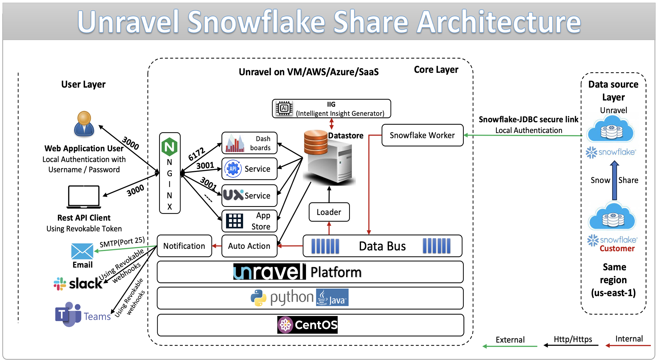

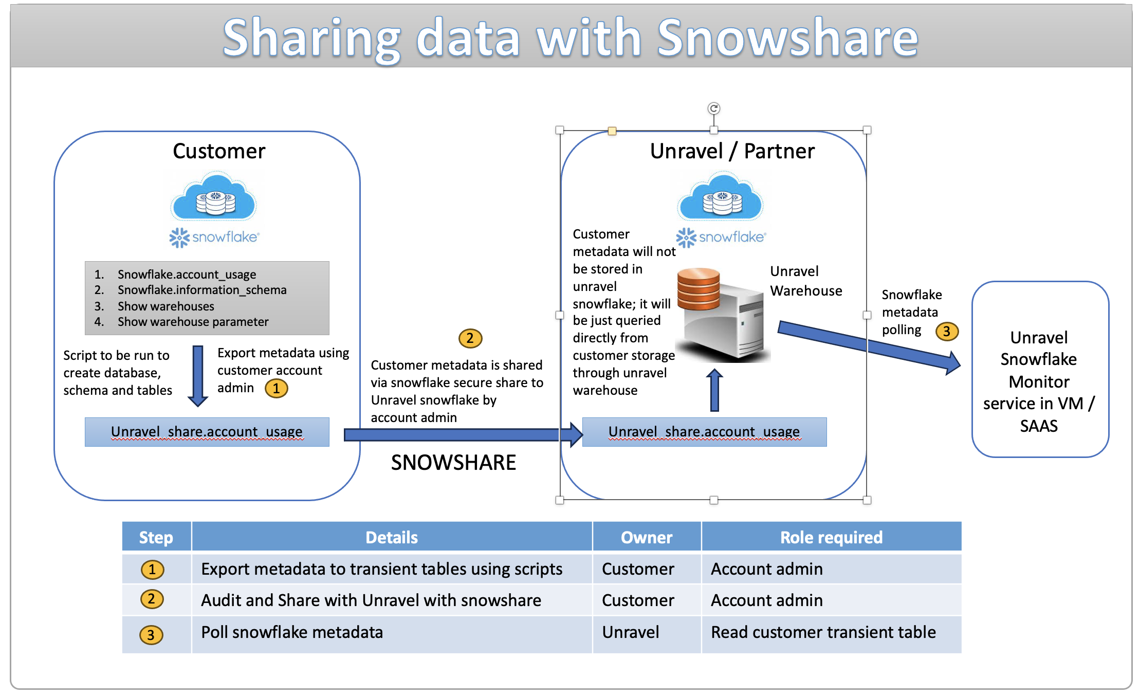

## Pre-requisite

1. **Snowflake account Access through snow share**
   * 1. Give user ACCOUNTADMIN role and GRANT SELECT on schema SNOWFLAKE.ACCOUNT_USAGE.
     2. Based on the latency required the task will cost.
     3. **Get the unravel account id for corresponding platform, region, and edition.**

## Data Collection

## Get customer health check account region.

## Get customer health check account platform.

## Get customer health check account type.

Based on this unravel account should be shared

|  |  |  |  |
| --- | --- | --- | --- |
| Platform | Region | Account type | Unravel Account |
| AWS | US-EAST-1 | < Business Critical | GDB63908 |
| AWS | EU-Ireland | < Business Critical | FL67243 |

## One time execution for health check for 15 days.

* Based on customer region and account type GDB63908 should be replaced with corresponding unravel account id, GDB63908 is in AWS US-EAST-1, Contact unravel for more details

<https://github.com/unraveldata-org/snowflake-data-loader/blob/main/script/snow_share/health_check_procedure.sql>

## Contact unravel to receive the data from unravel snowflake account with the customer’s name value given in script.

--Validate that the outbound share is available to the unravel account.

Show shares like '%SECURE%';